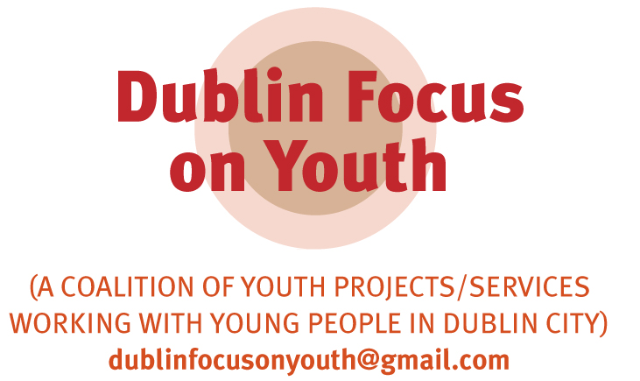

“If there were no youth workers or volunteers in this community I’d say it would fall flat on its face. The young people would get bored and I’d say it would be chaotic”
Michael Byrne, (YNOW magazine June 2009)

“It is our youth who will determine how 21st century Ireland meets the challenges of an increasingly globalised economy.”
An Taoiseach, Brain Cowen TD 7th May 2008

Pre Budget Submission by Dublin Focus on Youth

Proposal
- A reversal of the 2009 cuts to youth work funding in the Office of the Minister for Children and Youth Affairs and to LDTF funding in the Department of Education and Science and related funding in the Department of Community, Rural and Gaeltacht Affairs.
- Funding for youth work to be maintained at 2008 levels for 2010 in order to maintain all frontline services to the most vulnerable young people in Dublin today. It has been acknowledged by youth work organisations that the need among young people on the ground is far greater than the funding allocation for 2008.

Submitted by Dublin Focus on Youth
Dublin Focus on Youth is a coalition of frontline youth projects and services working with young people in Dublin City who are in receipt of funding from the City of Dublin Youth Service Board (CDYSB). The coalition was established in 2009 to raise the public profile of youth work and to highlight the potential impact of funding cut-backs on the work of its members and the young people with whom they work. The purpose of the coalition is to promote youth work and lobby, challenge and resist funding cut-backs in the youth work sector.

Rationale
1. Importance of Young People and Youth Work
Youth Work is a planned programme of education designed for the purpose of aiding and enhancing the personal and social development of young persons through their voluntary involvement, and which is complementary to formal academic education or training and is provided primarily by youth work organisations.

Youth work in Dublin city is strategically working in communities by providing key frontline services to young people who are most vulnerable in society. It provides opportunities for young people to develop better quality of life and to develop at an individual level, community and societal.

CDYSB funded projects/services in Dublin serve the needs of vulnerable young people who live in the most marginalised and disadvantaged areas characterised by the key deprivation indicators of high unemployment, early school leaving, high levels of substance misuse, lone parent families and low participation rates in higher education.

2. Current Situation
A total of 33790 young people participated in CDYSB funded youth projects/services in Dublin in 2008, 48% of these young people were aged between 10 – 14 years and a further 30% are aged 15 – 19 years.

A large number of volunteers support professionally qualified teams of youth workers at management board and committee levels. Youth work practice involves strategic working with An Garda Siochana, primary and secondary schools, HSE, Social Welfare and other Statutory, community and voluntary groups through collaborative working and referrals.

3. Achievements to date
The government has developed a very strong and successful youth work sector in the past ten years and a key development has been the Youth Work Act 2001. This has also resulted in a highly professional and regulated youth work sector operating within the principles of good governance.

The governments’ commitment during the Celtic Tiger has resulted in a developed infrastructure including 10 new state of the art facilities for young people and proposals for three further facilities. Almost 70 projects and services across Dublin city provide invaluable services to the local communities they serve.

However these services will struggle to continue to provide frontline services if further funding cuts are implemented in the upcoming budget. It is essential to protect, sustain and build on the investment that the government has made in youth work over the last number of years and ensure we maintain the levels of services and support for young people who will need these supports in the coming years more than ever.

4. Impact of Funding Cuts
Marginalised and vulnerable young people are most at risk during this recession and need the frontline services provided by these projects/services to deliver essential programmes at a time where they have little or no hope of employment at home or abroad.

CDYSB funded projects/services are a well developed network embedded in local communities who are uniquely positioned offering professional frontline services and support to this very vulnerable cohort of young people.

A reduction in funding for these projects/services will not in monetary terms be a saving but will in fact be an expense as the resultant consequences may be unemployment, prison, addiction and mental health problems at considerable cost to the State.

It costs approximately €420,000 per year per child for residential care, it costs €270,000 per year to keep a prisoner in Portlaoise and young offenders at St. Patrick’s Institute for Young Offenders cost the Sate €106,800 per year per individual. In 2006 mental health problems cost the State €3 billion, drug rehabilitation cost the Sate between €621 and €2733 per week.

Youth work provides vulnerable young people with professional frontline services to ensure that they have alternatives to the juvenile detention system, long term unemployment or drug misuse and in support of mental health services the youth work sector promotes psychological and emotional well being.

The total CDYSB budget for youth projects and services and backup support was less than €20 million in 2008. Based on 33,790 young people availing of the projects and services in 2008 this works out at less than €12 per young person per week. This is in stark contrast to the exceptionally high costs to the State of interventions highlighted above and represents very good value for money.

5 Youth Work Prevention & Intervention Profiled

Youth work projects/services engage in a wide range of interventions, programmes and supports. However, two areas are now outlined to demonstrate the nature of the work in more detail - work with young parents and responses to building capacity among young people.

Within the youth work sector many services work with and support young parents who are considered among the most vulnerable in society. The Crisis Pregnancy Agency Statistical Report 2006, ‘Teenage pregnancy data’ states that the rate of births to young females aged 15-19 in 1996 as 15.97% as the national average compared with the figure for Dublin city which was 25.2%. The national average for 2002 was 18.86% with the figure for Dublin city at 32.1%, considerably higher than the national average and an increase of nearly 7% on 1996. The second highest rate of pregnancy in the country included places such as Ballyfermot, Bluebell and Inchicore. It has also been confirmed that poverty plays a large part in teenage pregnancy, as stated by the Department of Health and Children in 2006, “There is a strong link between teenage pregnancy and deprivation” Evidence from the UK suggests that this disadvantage will persist into adulthood (Kemp et al, 2004).

The youth work sector engages in programmes that support young people in remaining in education, accessing alternative education, skills and career supports. The significant increase of unemployment across Dublin city is stark and its effects on young people will require even greater supports. Figures from the QNHS released by the CSO show the unemployment rate for March 2009 was 10.2% nationally, however in the areas where these youth projects/services are based the figures are much higher with the unemployment rate in Finglas standing at 19.4% and Dublin Inner City at 17.4% these figures are set to increase. Youth work provides positive options, experience and supports for young people in these areas who are most at risk of becoming long term unemployed.

Local communities have invested substantially in developing youth work projects/services and supports which have built up an enormous amount of social capital in these deprived areas. Further reductions in funding will impact negatively on these developments and may result in disillusionment by the young people, anger by their parents and a powerful response by the local communities.

6. Developing Ireland’s Future
Young people are Ireland’s future and one of its’ strongest resources that must be invested in. The distinctive features of youth work are the ability to relate and engage with young people in a meaningful way and to enable young people to maintain links and stay engaged with other supports and services such as the education system, the health system, social welfare, training and employment, being actively involved in their communities though active citizenship. Cuts in youth working funding will affect the local communities in which the young people live and society as a whole.

7. Conclusion
Local communities have invested substantially in developing youth work projects/services and supports which have built up an enormous amount of social capital in these deprived areas. Further reductions in funding will impact negatively on these developments and may result in disillusionment by the young people, anger by their parents and a powerful response by the local communities.

